
NAMES : GAHIGI Robert
Student ID:101101
FACULTY:INFORMATION AND TECHNOLOGY
PROGRAM: BIG DATA ANALYTICS

INTERNSHIP REPORT AT RWANDA METEOROLOGY AGENCY

Abstract
This internship was conducted at the Rwanda Meteorology Agency (Meteo Rwanda), where the primary focus was on meteorological data analysis, visualization, and data quality assessment. The internship aimed to strengthen practical skills in data science, particularly in handling real-world climate datasets.
During the internship, several key tasks were performed, including mapping meteorological stations across Rwanda using Python-based geospatial tools, developing a data quality control dashboard to monitor and evaluate meteorological data, and analyzing datasets from seven Automatic Weather Stations (AWS) located in Kigali. These stations included Gitega, Kivugiza, Rubungo, Jali, Gatenga, Nduba, and Rusororo.
The project emphasized improving data reliability, detecting missing values and anomalies, and providing insights into climate patterns. The results showed that data quality issues such as missing values and inconsistencies are common and can reduce the accuracy of weather predictions and decision-making.

1. Introduction
Meteorological data plays a critical role in supporting climate monitoring, disaster management, agriculture, and environmental planning. In Rwanda, extreme weather events such as heavy rainfall , floods and landslides have increased in recent years , making accurate weather data more important than ever .
This internship was carried out at the Rwanda Meteorology Agency (Meteo Rwanda), an institution that is responsible for collecting, analyzing, and disseminating weather and climate information. However , challenges such as missing data and inconsistent records affect the reliability of this information .
The main objective of the internship was to apply data science techniques to improve data analysis and quality control processes within the organization.
The internship focused on three main areas:
- Mapping meteorological stations across Rwanda
- Developing a data quality control dashboard
- Analyzing meteorological data from selected AWS stations in Kigali
Through these activities, the internship provided me ,an opportunity to bridge theoretical knowledge in Big Data Analytics with real-world applications in climate science.

2. METHODOLOGY

2.1 Data collection

Meteorological data was collected from seven AWS stations in Kigali :Gitega , Kivugiza ,Rubungo , Jali, Gatenga , Nduba and Rusororo . These stations record variables such as rainfall , temperature , humidity and windspeed.

2.2 Data cleaning

The raw datasets contained missing values , incorrect formats, and inconsistencies . The following steps were applied:
- Removal of missing and invalid values
- Correction of date and time formats
- Removal of duplicate records
- Standardization of variable names

2.3 Data Integration

Different datasets had different time resolutions . Rainfall data was daily , while wind data was hourly . To combine them :
- Hourly data was aggregated into daily values
- Datasets were merged using Date and District

2.3 Data Analysis Techniques

The following analyses were performed :
- Missing data analysis
- Outlier detection using statistical methods
- Trend analysis ( rainfall and temperature)

3 Data Quality Assessment

To evaluate data quality , the following metrics were used :
3.1 completeness

Completeness= Available Data * 100
Expected Data

3.2 Missing Data

Missing = Expected Data – Available Data

3.3 Data Quality Score

DQ Score = Completeness – Error rate

Interpretation: A high data quality score indicates reliable data , while a low score indicates poor data quality

4 . Internship Activities

4.1Meteorological Station Mapping using Python
One of the key activities during the internship was the mapping of meteorological stations across Rwanda. This task involved using Python libraries such as Pandas, Folium, and GeoPandas to visualize station locations on an interactive map.
The process included cleaning station datasets, handling missing geographical coordinates, and integrating shapefiles representing administrative boundaries of Rwanda. Custom icons were used to distinguish between different types of stations, such as Automatic Weather Stations (AWS) and manual stations.
The final output was an interactive map that allows users to explore station locations, improving spatial understanding of meteorological coverage across the country.
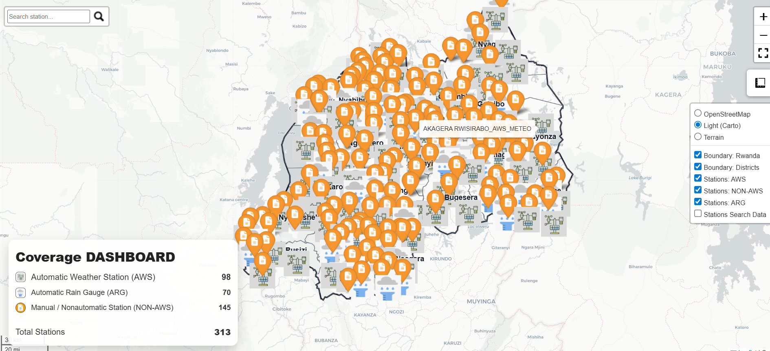

4.2 Development of Data Quality Control Dashboard
Another major activity involved designing and developing a data quality control dashboard. The purpose of this dashboard was to monitor the quality of meteorological data and identify issues such as missing records, inconsistencies, and anomalies.
The dashboard was developed using Django for the backend and visualization tools such as Chart.js for displaying key metrics. Several Key Performance Indicators (KPIs) were implemented, including:
- Total expected observations
- Available data records
- Missing data
- Data quality score
The system allowed users to filter data by station, time period, and frequency (hourly, daily, monthly), providing flexibility in analysis.
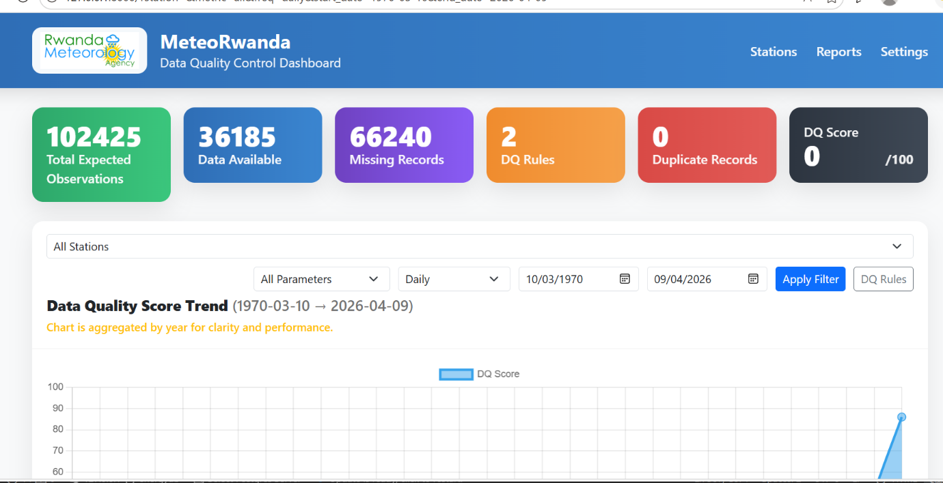
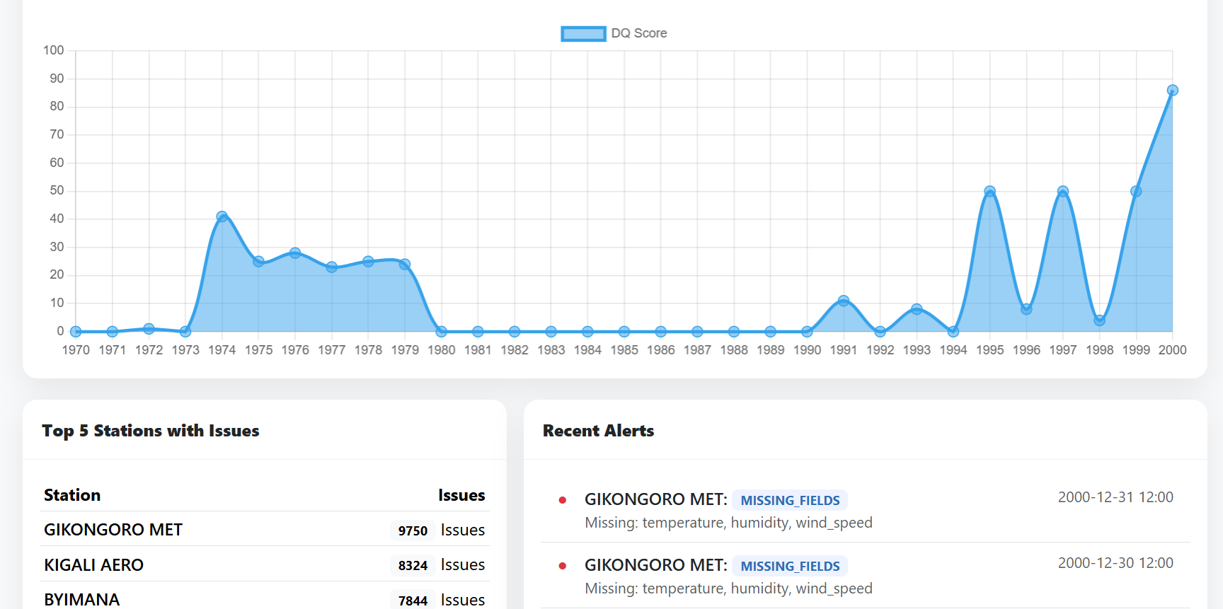
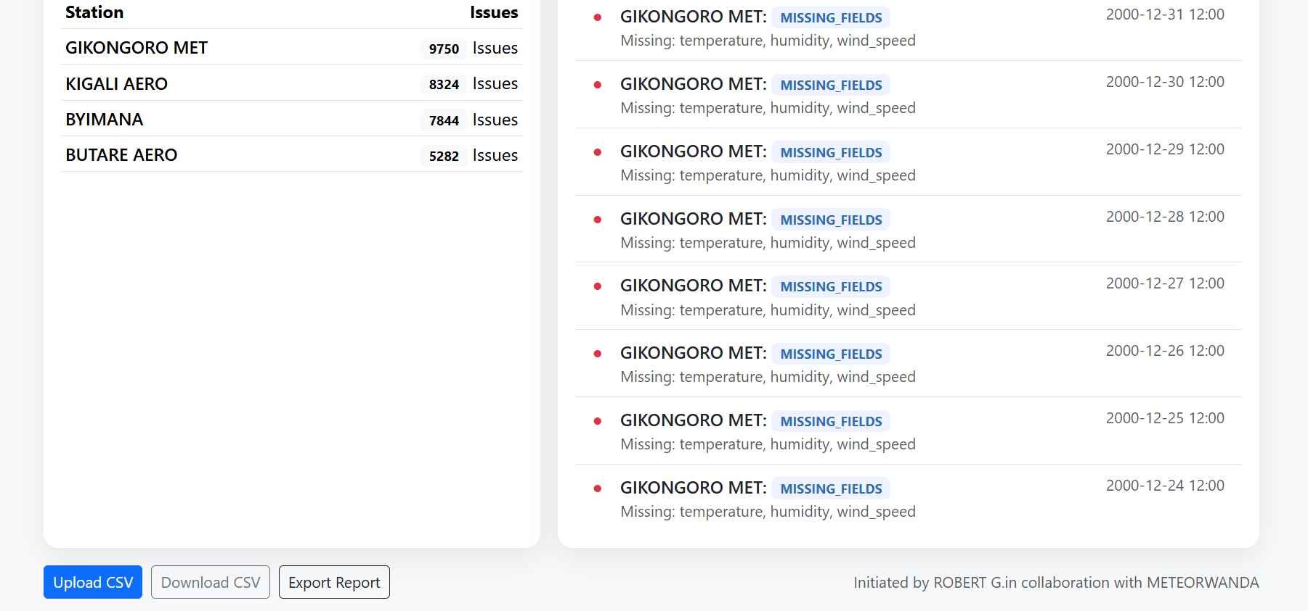
Interpretation: The dashboard displays key indicators such as available data, missing data , and data quality score. It helps to identify data problems quickly and improves monitoring efficiency

4.3 Analysis of AWS Station Data in Kigali
The final activity focused on analyzing meteorological data collected from seven AWS stations located in Kigali:
Gitega, Kivugiza, Rubungo, Jali, Gatenga, Nduba, and Rusororo.
The analysis included:
- Missing data analysis
- Outlier detection using statistical methods
- Homogeneity checks
- Trend analysis of key variables such as rainfall and temperature
These analyses helped identify data gaps and inconsistencies, as well as provide insights into local climate patterns.
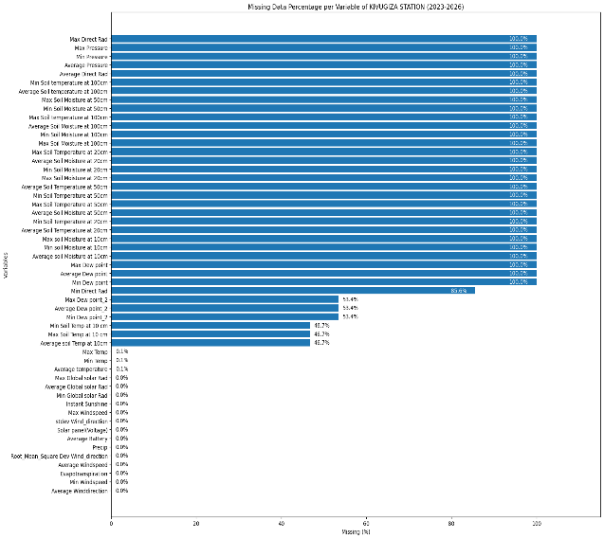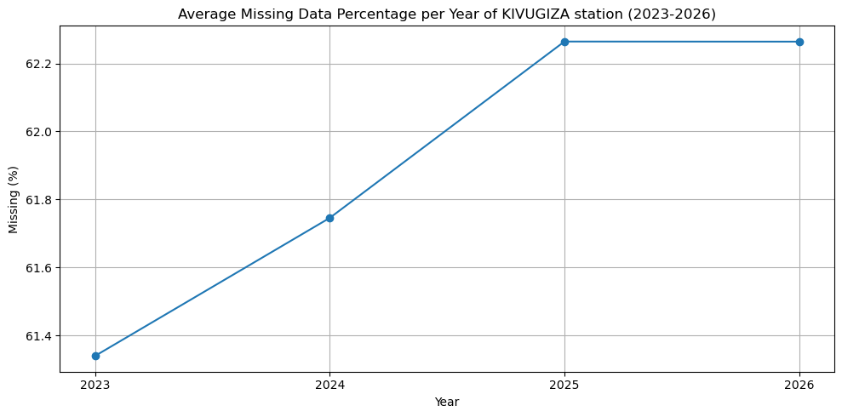
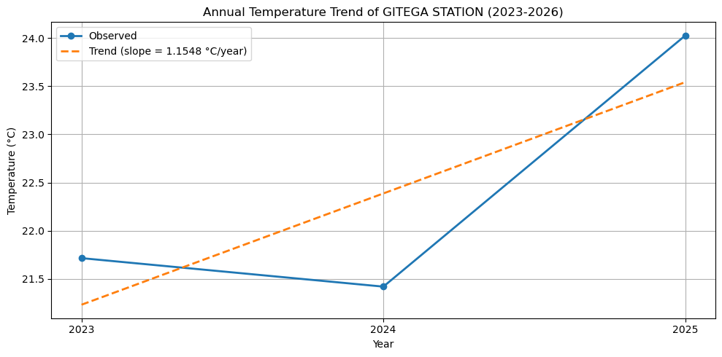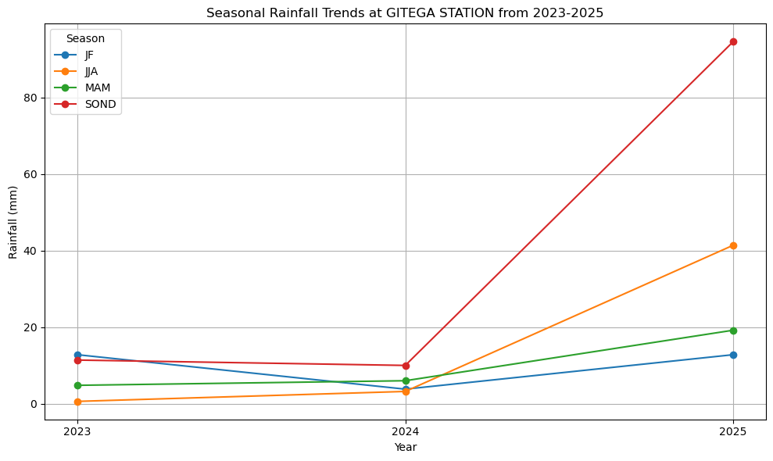
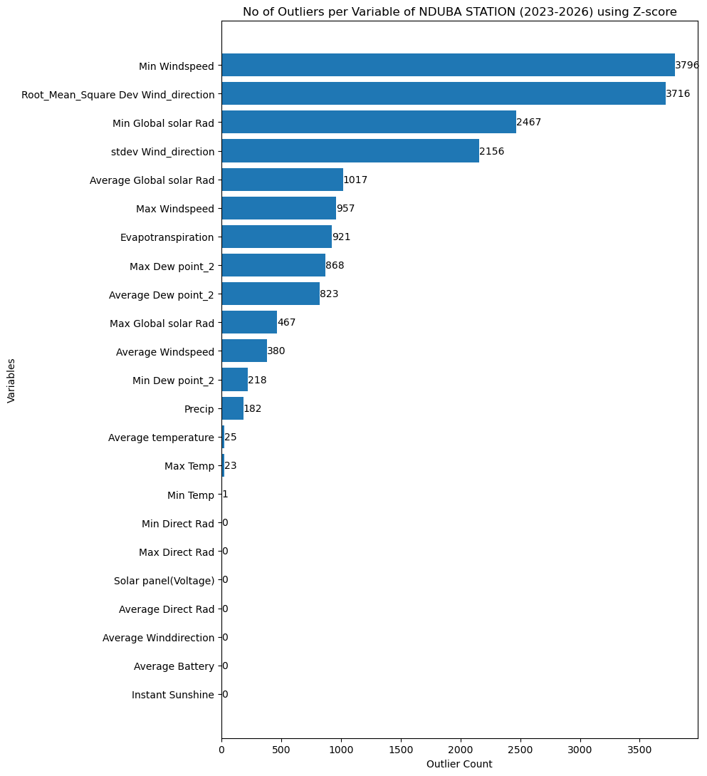
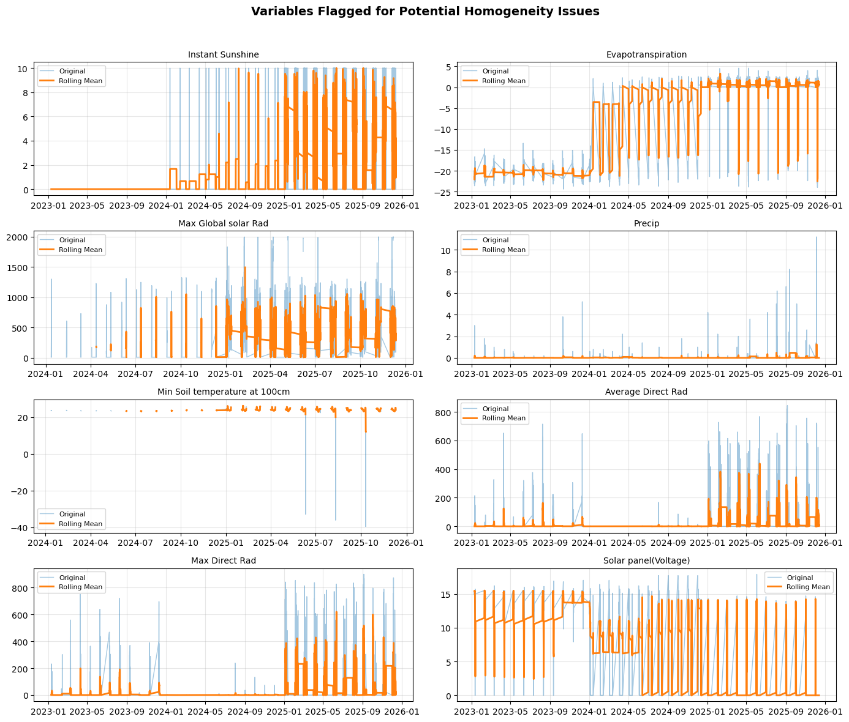
Interpretation : The analysis reveaveled that variability in rainfall and temperature . Missing data and outliers were detected , indicating possible sensor errors or extreme weather conditions .

3. Challenges
During the internship at the Rwanda Meteorology Agency (Meteo Rwanda), several challenges were encountered across technical, data-related, and operational aspects.
One of the major challenges was data inconsistency and missing values within meteorological datasets. Many datasets contained gaps due to sensor failures, communication issues, or irregular data transmission from Automatic Weather Stations (AWS). This required extensive preprocessing, including handling missing values and ensuring data integrity before analysis could be performed.
Another significant challenge was the integration of datasets with different temporal resolutions. For instance, rainfall data was often recorded on a daily basis, whereas other variables such as temperature, humidity, wind speed and wind direction were recorded hourly and 10-minutes interval. Aligning these datasets for combined analysis required careful aggregation and synchronization techniques to avoid data loss or misinterpretation.
Additionally, geospatial data handling (inconsistent geographical information ) posed challenges during the station mapping process. Some stations lacked complete geographical coordinates, while inconsistencies in naming conventions made it difficult to accurately map stations to districts. This required additional data cleaning and validation steps.
From a system development perspective, building the data quality control dashboard involved challenges related to backend integration, real-time data processing, and visualization design. Ensuring that the dashboard remained efficient and responsive while handling large datasets required optimization of queries and data structures.
Finally, limited availability of complete historical datasets and occasional inconsistencies in metadata affected the depth of analysis.(Time frame for the available data that was used for analysis :2023-2025/2026) .Despite these challenges, appropriate data preprocessing and validation techniques were applied to ensure reliable outcomes.

4. Results
The internship produced several significant results that contribute to improving meteorological data management and analysis in Rwanda.
Firstly, the development of an interactive meteorological station map provided a comprehensive spatial overview of station distribution across the country. This visualization enhances decision-making by identifying areas with dense or sparse station coverage, which is critical for improving national weather monitoring systems.
Secondly, the implementation of the data quality control dashboard represents a major advancement in monitoring meteorological data reliability. The dashboard enables real-time assessment of data completeness and quality through clearly defined Key Performance Indicators (KPIs), such as data availability, missing records, and overall data quality score. This system supports proactive identification of data issues, thereby improving the accuracy of climate information.
Thirdly, the analysis of AWS station data from Kigali revealed important insights into data quality patterns and climate behavior. The results showed that:
- Certain stations experienced higher levels of missing data, indicating possible technical or maintenance issues.
- Variability in rainfall and temperature patterns reflects the localized nature of urban climate dynamics in Kigali.
- Outlier detection highlighted abnormal readings, which may be associated with sensor errors or extreme weather events.
From a broader perspective, these findings are particularly relevant in the context of Rwanda’s increasing vulnerability to climate-related hazards, such as floods and landslides. Accurate and reliable meteorological data is essential for early warning systems and disaster risk reduction strategies.
Overall, the internship demonstrated that integrating data science techniques with meteorological data can significantly enhance the efficiency, reliability, and usability of climate information systems.

5. Conclusions
In conclusion, the internship at the Rwanda Meteorology Agency provided valuable practical experience in applying data science techniques to real-world meteorological challenges. The work carried out during this period successfully addressed key aspects of data visualization, data quality assessment, and climate data analysis.
The development of tools such as the interactive station map and the data quality control dashboard contributes to improving the management and interpretation of meteorological data. These tools have the potential to support better decision-making in sectors such as agriculture, disaster management, and environmental planning.
Furthermore, the analysis of AWS station data highlighted the importance of maintaining high-quality datasets to ensure accurate climate monitoring and forecasting. The internship reinforced the critical role of data quality in supporting reliable weather predictions and early warning systems.
This experience has strengthened both technical and analytical skills, particularly in Python programming, data visualization, and statistical analysis, while also providing insights into the operational challenges of working with real-world data.

6. Reflection
The internship experience at Meteo Rwanda was highly enriching and provided an opportunity to bridge theoretical knowledge with practical application. It allowed for the development of key competencies in data analysis, problem-solving, and system design within a real-world institutional environment.
One of the most valuable aspects of the internship was the exposure to real meteorological datasets, which are often complex, incomplete, and unstructured. This experience improved the ability to handle data quality issues and apply appropriate preprocessing techniques.
Additionally, the process of developing the data quality dashboard enhanced understanding of full-stack system development, including backend logic, data handling, and user interface design. It also emphasized the importance of creating user-friendly tools that can be effectively used by non-technical stakeholders.
The internship also highlighted the importance of interdisciplinary collaboration, as meteorological data analysis intersects with environmental science, disaster management, and policy-making.
Overall, this experience has significantly contributed to professional growth and has provided a strong foundation for future work in data science and climate analytics.

7. Acknowledgements
I would like to express my sincere gratitude to the Rwanda Meteorology Agency (Meteo Rwanda) for providing me with the opportunity to undertake this internship and gain valuable practical experience.
I am particularly grateful to my supervisors ,specifically MR.Herve MURENZI and mentors at Meteo Rwanda for their continuous guidance, support, and encouragement throughout the internship period. Their expertise and insights were instrumental in the successful completion of this work.
I would also like to thank the faculty members of the Adventist University of Central Africa (AUCA), especially my academic supervisor, for their guidance and support during this internship.
Finally, I extend my appreciation to all colleagues and staff members who contributed directly or indirectly to the success of this internship.

